Assignment of the Problem: 21.10.2024

Date of Submission: 08.11.2024

Problem 8: Case Study of Graph Manipulation Algorithms: You are required to apply the following algorithms on the Network graph shown in Figure 1.

1. Assume **a** as initial vertex to traverse the graph shown in Figure 1 then what will be final output when applied the following algorithms.
   1. Breadth First Search
   2. Depth First Search
2. Find the minimum spanning tree using the following algorithms.
   1. Prim’s Algorithm
   2. Kruskal’s Algorithm

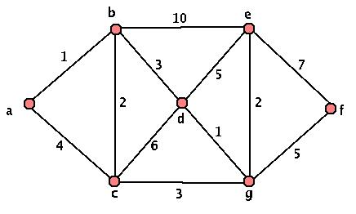

Figure 1. Network Graph